K L (DEEMED TO BE) UNIVERSITY
DEPARTMENT OF COMPUTER SCIENCE AND ENGINEERING
PROJECT REPORT
“LINUX FILE DESCRIPTOR AND FILE I/O MANAGEMENT SYSTEM”
A Project Report Submitted in partial fulfillment of the requirements
for the award of the degree of
BACHELOR OF TECHNOLOGY
in
COMPUTER SCIENCE AND ENGINEERING
BY
S. No. | Student Name | Roll Number
1 | K. Akshitha Reddy | 2520030233
2 | T. Meghana Sai | 2520030245

Under the Esteemed Guidance of
K.HEMA
Department of Computer Science and Engineering
Academic Year 2026–2027

DECLARATION
We hereby declare that the project report entitled “Linux File Descriptor and File I/O Management System” is a bonafide work carried out by us in partial fulfillment of the requirements for the award of the Bachelor of Technology degree in Computer Science and Engineering.
The project was developed in the Ubuntu Linux environment using C programming and Linux/POSIX system calls. The work focuses on practical file descriptor management and low-level file input/output operations.
We further declare that the work presented in this report is our own implementation and has not been copied from any other department, university, or institute.

Student Name | Roll Number | Signature
K. Akshitha Reddy | 2520030233 | ________________
T. Meghana Sai | 2520030245 | ________________

CERTIFICATE
This is to certify that the project report entitled “Linux File Descriptor and File I/O Management System” is a bonafide work carried out and submitted by K. Akshitha Reddy (2520030233), T. Meghana Sai (2520030245), and in partial fulfillment of the requirements for the award of the degree of Bachelor of Technology in Computer Science and Engineering during the academic year 2026–2027.
The project work demonstrates the application of Linux system programming concepts, file descriptors, file I/O system calls, file access flags, error handling, and command-line execution in Ubuntu Linux.

Guide Signature | Course Coordinator | HOD
________________ | ________________ | ________________
Date: ___________ | Date: ___________ | Date: ___________

ACKNOWLEDGEMENT
We express our sincere gratitude to the faculty members and project guide of the Department of Computer Science and Engineering for their valuable guidance, encouragement, and support throughout the development of this project.
We are thankful to the Head of the Department and the course coordinator for providing the facilities and academic environment required to complete this Operating Systems project. Their suggestions helped us understand Linux system calls and practical file management concepts more clearly.
We also thank our teaching and non-teaching staff, classmates, friends, and family members for their cooperation and encouragement during the implementation, testing, documentation, and presentation of the project.
Finally, we thank everyone who directly or indirectly contributed to the successful completion of the Linux File Descriptor and File I/O Management System.

ABSTRACT
The Linux File Descriptor and File I/O Management System is a C-based Operating Systems and Systems Programming project developed and executed in the Ubuntu Linux environment to demonstrate how Linux manages files through file descriptors and system calls. A file descriptor is an integer assigned by the operating system to an opened file, which allows a process to perform various input/output operations on that file. The project provides a menu-driven command-line interface through which users can create, open, read, write, append, seek, and manage files.
The system is organized into multiple functional modules, including File Manager, File I/O Operations, File Descriptor Management, File Information, File Management, Advanced I/O, and System Information. It supports operations such as reading and writing data, accessing specific file positions, displaying and selecting active file descriptors, duplicating descriptors using dup() and dup2(), and closing individual or multiple descriptors. The system also provides file metadata such as file size, permissions, type, and current file position using fstat() and related Linux mechanisms.
Advanced file operations are demonstrated using fcntl() for file-descriptor flags and file locking, fsync() for file synchronization, and ftruncate() for modifying file size. File management features include renaming, deleting, creating directories, changing permissions using chmod(), and maintaining persistent operation history. The System Information module demonstrates standard file descriptors, process IDs, total open descriptors, and process descriptor information through the /proc/<PID>/fd interface.
The project provides practical understanding of the interaction between a user program, Linux system calls, file descriptors, the Linux kernel, and the file system. It was implemented using C and GCC and tested through the Ubuntu terminal. The project demonstrates important Operating Systems concepts through a practical and interactive file-management application.

INDEX
Chapter | Topic / Subtopic | Page
1 | Introduction | 7
1.1 | Background of the Project | 7
1.2 | Problem Statement | 8
1.3 | Scope of the Project | 8
1.4 | Objectives of the Project | 10
1.5 | Importance of the Application | 11
1.6 | Target Users / Audience | 12
2 | OS Concepts and Background Study | 13
2.1 | Operating System Concepts Related to the Project | 14
2.2 | Existing Methods / Algorithms | 26
2.3 | Proposed Approach | 27
2.4 | Advantages of the Proposed Approach | 29
2.5 | Relationship Between the Concepts | 31
2.6 | Chapter Summary | 32
3 | System Requirements | 33
3.1 | Hardware Requirements | 34
3.2 | Software Requirements | 34
3.3 | Operating System Environment – Ubuntu Linux | 35
3.4 | Development Tools and Compiler | 37
3.5 | Linux Terminal | 39
3.6 | Git and GitHub | 40
3.7 | Project Storage Requirements | 41
3.8 | Runtime Requirements | 42
3.9 | Summary of System Requirements | 43
3.10 | Chapter Summary | 43
4 | Technology and Tools Used | 44
4.1 | C Programming | 45
4.2 | GCC Compiler | 46
4.3 | Linux System Calls / APIs | 47
4.4 | Linux Commands and Utilities | 57
4.5 | Ubuntu Linux Environment | 58
4.6 | Development Tools | 59
4.7 | Project Development Environment | 60
4.8 | Git and GitHub | 60
4.9 | Development Environment | 60
4.10 | Technology Summary | 61
4.11 | Chapter Summary | 61
5 | System Architecture and Design | 62
5.1 | Overall System Architecture | 62
5.2 | System Workflow | 68
5.3 | Flowchart / Data Flow | 70
5.4 | Module Description | 72
5.5 | Input and Output Design | 80
5.6 | File Descriptor Management Design | 82
5.7 | File Information Design | 84
5.8 | Advanced I/O Design | 86
5.9 | Data and Operation History Design | 88
5.10 | Error Handling Design | 89
5.11 | Design Summary | 91
5.12 | Chapter Summary | 92
6 | Implementation | 93
6.1 | Module-wise Implementation | 93
6.2 | Algorithm / Pseudocode | 97
6.3 | Core C Implementation | 98
6.4 | Linux System Calls / APIs Used | 100
6.5 | File Access Flags and Permissions | 102
6.6 | Error Handling | 103
6.7 | Persistent Data and History | 104
6.8 | Compilation and Execution | 105
6.9 | Implementation Summary | 106
6.10 | Chapter Summary | 106
7 | Execution and Demonstration | 107
7.1 | Compilation in Ubuntu | 107
7.2 | Execution Commands | 108
7.3 | Sample Inputs and Outputs | 108
7.4 | Screenshots of Execution | 110
7.5 | Demonstration of OS Concepts | 114
7.6 | Testing and Validation | 115
7.7 | Chapter Summary | 116
8 | Conclusion and Future Scope | 116
8.1 | Summary of the Project | 116
8.2 | Objectives Achieved | 117
8.3 | Results Achieved | 118
8.4 | Skills and Learning Outcomes | 119
8.5 | Future Enhancements | 119
8.6 | Conclusion | 120
9 | References | 120
9.1 | Books | 120
9.2 | Linux / GNU Documentation | 121
9.3 | Linux System Calls and POSIX References | 121
9.4 | Linux Commands and Utilities | 122
9.5 | Project Repository | 123
9.6 | Online Resources | 123
9.7 | Reference Summary | 123
------ | Appendix – A: Quick Viva / Demonstration Notes | 125
------ | Annexure – A: Project Problem Statement Details | 126

CHAPTER – 1 INTRODUCTION
1.1 Background of the Project
Operating systems provide the basic services required for applications to communicate with hardware and manage system resources. File management is one of the important responsibilities of an operating system. In Linux, files and other input/output resources are accessed by processes through file descriptors, which are integer values associated with opened files.
A C program can interact with files using Linux system calls instead of directly controlling the storage hardware. When the open() system call successfully opens or creates a file, the Linux kernel returns a file descriptor to the program. This descriptor is then used with system calls such as read(), write(), lseek(), and close() to perform file input/output operations.
The Linux File Descriptor and File I/O Management System was developed as a practical system-programming application to demonstrate these concepts in the Ubuntu Linux environment. The project provides a menu-driven command-line interface through which users can create, open, read, write, append, seek, and manage files.
The developed system goes beyond basic file operations by providing separate modules for file descriptor management, file information, file management, advanced I/O operations, and system information. It demonstrates operations such as file descriptor duplication using dup() and dup2(), file metadata retrieval using fstat(), file locking and descriptor control using fcntl(), file synchronization using fsync(), and file-size modification using ftruncate().
The project therefore provides a practical connection between the user program, Linux system calls, file descriptors, the Linux kernel, and the file system. The project was implemented in C using GCC on Ubuntu Linux and tested through the Ubuntu terminal.

1.2 Problem Statement
Understanding file descriptors and Linux system calls can be difficult for students when the concepts are studied only theoretically. In Linux, common file operations such as opening, reading, writing, appending, seeking, and closing are performed using different system calls and are controlled through file descriptors.
Beginners may find it difficult to understand how a file is opened by a process, how the operating system assigns a file descriptor, how the descriptor is used for subsequent I/O operations, and how the descriptor is finally released.
There is also a need to understand additional file-management concepts such as descriptor duplication, file permissions, file metadata, file locking, synchronization, truncation, and process-level file descriptor information.
Therefore, this project develops a Linux File Descriptor and File I/O Management System that provides a simple, menu-driven environment for performing and observing different file operations. The system demonstrates the interaction between a C application and the Linux operating system using file descriptors and Linux/POSIX system calls.
The project aims to convert theoretical Operating Systems and Systems Programming concepts into a practical application that can be executed, tested, and demonstrated in Ubuntu Linux.

1.3 Scope of the Project
The scope of the project includes the development of a menu-driven Linux application for managing files and demonstrating file-descriptor-based operations.
The system provides the following functionality:
File Manager
- Create a new file.
- Open an existing saved file.
- Create a file if it does not exist.
- List saved files.
- Select an active file.
File I/O Operations
- Read data from a file.
- Write data to a file.
- Append data to a file.
- Change the current file position using lseek().
- Read data from a specific file position.
- Write data at a specific file position.
File Descriptor Management
- Display currently open file descriptors.
- Duplicate a file descriptor using dup().
- Duplicate a file descriptor to a specific descriptor using dup2().
- Close an individual file descriptor.
- Close all managed file descriptors.
- Select an active file descriptor.
File Information
- Display complete file information.
- Display file permissions.
- Display file size.
- Display the current file position.
- Identify the file type.
File Management
- List saved files.
- Rename files.
- Delete files.
- Create directories.
- Change file permissions using chmod().
- Maintain and display operation history.
Advanced I/O
- Display file-descriptor flags using fcntl().
- Demonstrate file locking.
- Synchronize file data using fsync().
- Change file size using ftruncate().
System Information
- Display standard file descriptors.
- Display process file-descriptor information.
- Display the current process ID.
- Display the total number of open file descriptors.
- View operation history.
The application stores project-managed files inside the project data/ directory and maintains operation history in the logs/operations.log file. The project is designed for execution and demonstration in the Ubuntu Linux environment.

1.4 Objectives of the Project
The main objectives of the Linux File Descriptor and File I/O Management System are:
- To understand the concept and purpose of Linux file descriptors.
- To implement file input/output operations using Linux/POSIX system calls.
- To demonstrate file creation and opening using open().
- To perform low-level file reading and writing using read() and write().
- To demonstrate appending and file-position management using appropriate file-opening flags and lseek().
- To demonstrate reading and writing from specific file positions.
- To understand file descriptor duplication using dup() and dup2().
- To demonstrate proper file descriptor management through selection and closing of descriptors.
- To retrieve and display file metadata such as size, permissions, type, and current position.
- To implement file-management operations such as rename, delete, directory creation, and permission modification.
- To demonstrate advanced file operations such as descriptor flags, file locking, synchronization, and file truncation.
- To understand process-level file descriptor information using the Linux /proc file system.
- To provide persistent operation history for file-management activities.
- To execute and test the complete application in Ubuntu Linux using GCC.
- To connect theoretical Operating Systems concepts with practical Linux system programming.

1.5 Importance of the Application
The application is important because it provides a practical way to understand how Linux handles files and file descriptors.
In a theoretical explanation, students learn that the operating system assigns a file descriptor when a file is opened. However, observing the actual descriptor and using it for different operations provides a clearer understanding of the concept.
The project demonstrates the complete basic flow:
User
↓
Menu-driven C Application
↓
Linux System Call
↓
File Descriptor
↓
Linux Kernel
↓
File System
The application helps students understand how a user-level program requests services from the Linux kernel through system calls.
It also provides practical demonstrations of important Operating Systems concepts such as:
- File descriptors
- System calls
- File I/O
- File offsets
- File permissions
- Descriptor duplication
- File metadata
- File locking
- File synchronization
- File truncation
- Process IDs
- Process file descriptors
- /proc file system
- Resource management
The menu-driven design makes the project suitable for laboratory demonstrations because each operation can be selected and its result can be observed directly from the terminal.
The project also provides a structured approach to file management instead of requiring separate Linux commands for every operation. This makes it easier for students to connect the underlying system calls with the corresponding file-management operation.

1.6 Target Users / Audience
The project is primarily intended for:
1. Computer Science and Engineering Students
Students studying Operating Systems and Systems Programming can use the application to understand file descriptors and Linux system calls through practical execution.
2. Students Learning C System Programming
The project demonstrates how C programs interact with the Linux operating system using low-level system calls.
3. Operating Systems Laboratory Students
The menu-driven application can be used for laboratory demonstrations involving file I/O, descriptor management, permissions, and process information.
4. Faculty Members
Faculty members can use the project to demonstrate concepts such as open(), read(), write(), lseek(), dup(), dup2(), fcntl(), fsync(), and ftruncate().
5. Beginners Learning Linux
Students who are new to Linux file handling can use the project to understand the relationship between files, file descriptors, system calls, and the Linux kernel.

Chapter 1 Summary
This chapter introduced the Linux File Descriptor and File I/O Management System, its problem background, scope, objectives, importance, and intended users. The project provides a practical implementation of Linux file-management concepts using C and system calls in Ubuntu Linux. The following chapters will explain the Operating Systems concepts, requirements, technologies, architecture, implementation, and execution of the developed system.

CHAPTER – 2
OS CONCEPTS AND BACKGROUND STUDY
2.1 Operating System Concepts Related to the Project
The Linux File Descriptor and File I/O Management System is based on important Operating Systems and Systems Programming concepts related to file management, process resources, system calls, and low-level input/output. The project demonstrates these concepts practically in the Ubuntu Linux environment.
The major concepts used in the project are file descriptors, system calls, file I/O, file offsets, file permissions, processes, file descriptor duplication, file metadata, file locking, synchronization, and the /proc file system. The original project documentation also identifies file descriptors, system calls, file I/O, file offsets, permissions, the kernel, and processes as the primary concepts behind the system. Linux_File_Descriptor_and_File_…

2.1.1 File Descriptors
A file descriptor (FD) is a non-negative integer used by a Linux process to identify an open file or another input/output resource.
When a process successfully opens a file using open(), the Linux kernel returns a file descriptor. The application then uses this integer with other system calls to perform operations on the opened file.
The basic relationship can be represented as:
File
↓
open()
↓
File Descriptor
↓
read() / write() / lseek()
↓
close()
For example, if open() returns:
File Descriptor : 3
the application can use FD 3 for subsequent file operations.
In this project, file descriptors are stored and managed by the File Descriptor Management module. The application displays currently open descriptors and allows the user to select an active descriptor, duplicate descriptors, and close descriptors.
File descriptors are important because they provide the connection between the application and the file managed by the Linux kernel.

2.1.2 Standard File Descriptors
Every normal Linux process starts with three standard file descriptors:
File Descriptor | Name | Purpose
0 | Standard Input (stdin) | Receives input
1 | Standard Output (stdout) | Displays normal output
2 | Standard Error (stderr) | Displays error messages
When the application opens additional files, Linux normally assigns available descriptor numbers such as 3, 4, 5, and so on.
For example:
FD 0 → Standard Input
FD 1 → Standard Output
FD 2 → Standard Error
FD 3 → Opened File
FD 4 → Another Opened File
The System Information module of the project displays these standard descriptors and also shows the additional descriptors currently associated with the running process.
The project documentation specifically identifies descriptors 0, 1, and 2 as standard input, output, and error, while descriptors such as 3 and above can represent application-opened files. Linux_File_Descriptor_and_File_…

2.1.3 System Calls
A system call is a controlled mechanism through which a user-level program requests a service from the operating system kernel.
Applications cannot directly perform all hardware and operating-system resource operations. Instead, they request services from the Linux kernel through system calls.
The project uses several Linux/POSIX system calls, including:
- open()
- read()
- write()
- close()
- lseek()
- dup()
- dup2()
- fstat()
- rename()
- unlink()
- mkdir()
- chmod()
- fcntl()
- fsync()
- ftruncate()
- getpid()
The basic interaction is:
User
↓
C Application
↓
System Call
↓
Linux Kernel
↓
File / File System
This interaction is one of the main Operating Systems concepts demonstrated by the project.

2.1.4 File Input and Output
File Input/Output (File I/O) refers to transferring data between a program and a file.
In this project, file I/O is performed primarily through file descriptors and low-level Linux system calls.
The main operations are:
Reading
The read() system call transfers data from an opened file into a buffer in the program.
File → read() → Program Buffer
Writing
The write() system call transfers data from the program into a file.
Program Buffer → write() → File
Appending
Appending adds new data at the end of an existing file. The project uses appropriate file-opening behavior such as O_APPEND to demonstrate this operation.
Closing
The close() system call releases an open file descriptor when it is no longer required.
The project documentation identifies open(), read(), write(), and close() as the basic Linux/POSIX file I/O interface used for demonstrating kernel-managed file descriptors. Linux_File_Descriptor_and_File_…

2.1.5 File Offset and File Position
A file descriptor has an associated current file position, also called the file offset.
The offset determines where the next read or write operation will occur.
For example:
File:
------------------------------------------------
0 1 2 3 4 5 6 7 8 9 ...
^
Current Position
The lseek() system call is used to change this position.
The project demonstrates:
- Seeking to a new position.
- Reading from a specific position.
- Writing at a specific position.
- Displaying the current file position.
The general concept is:
Current Position
↓
lseek()
↓
New File Position
↓
read() / write()
This allows the user to understand that file I/O does not always have to occur sequentially from the beginning of a file.

2.1.6 File Access Modes and Flags
Linux provides different access modes and flags when a file is opened.
The project uses flags such as:
Flag | Purpose
O_RDONLY | Open for reading
O_WRONLY | Open for writing
O_RDWR | Open for reading and writing
O_CREAT | Create file if it does not exist
O_EXCL | Ensure exclusive creation of a new file
O_TRUNC | Truncate an existing file
O_APPEND | Write data at the end of the file
For example, a file can be opened for both reading and writing using:
O_RDWR
A file can be created when it does not already exist using:
O_CREAT
These flags allow the application to control how a file is accessed.

2.1.7 File Permissions
Linux provides file permissions to control access to files and directories.
The three main permission categories are:
- Owner
- Group
- Others
The three basic permissions are:
- r – Read
- w – Write
- x – Execute
For example:
-rw-r--r--
represents:
Owner → read + write
Group → read
Others → read
The project demonstrates file permissions through:
- Displaying permissions.
- Changing permissions using chmod().
- Displaying the resulting permission information.
File creation can also use permission values such as:
0644
The original project documentation also identifies file access modes, flags, and permission values such as 0644 as part of the project concepts. Linux_File_Descriptor_and_File_…

2.1.8 File Metadata
File metadata contains information about a file other than its actual content.
The project uses fstat() to obtain information associated with an open file descriptor.
The application can display information such as:
- File size
- File permissions
- File type
- File status information
- Current file position
For example:
File Descriptor : 3
File Size : 107 bytes
File Type : Regular File
Permissions : 0644
Current Position: 0 bytes
This demonstrates how an application can obtain file information through the operating system.

2.1.9 File Descriptor Duplication
Linux provides mechanisms for creating duplicate file descriptors.
The project demonstrates two important operations:
dup()
dup() creates a new file descriptor that refers to the same open file description as an existing descriptor.
Conceptually:
FD 3
↓
dup()
↓
FD 4
Both descriptors can refer to the same opened file.
dup2()
dup2() allows a descriptor to be duplicated to a specified descriptor number.
For example:
Original FD : 3
Target FD : 10

dup2(3, 10)
After successful execution, FD 10 refers to the same open file description.
The project includes both dup() and dup2() under the File Descriptor Management module.
The original project proposal specifically identifies dup() and dup2() as descriptor-management APIs. Linux_File_Descriptor_and_File_…

2.1.10 File Descriptor Management
A process may have multiple files open at the same time. Therefore, managing open descriptors is important.
The project maintains an internal FD table containing information such as:
FD
File Name
Active Status
The File Descriptor Management module allows the user to:
- Display open file descriptors.
- Duplicate an FD using dup().
- Duplicate an FD using dup2().
- Close an individual FD.
- Close all managed FDs.
- Select an active FD.
The concept can be represented as:
Process
│
├── FD 0 → stdin
├── FD 1 → stdout
├── FD 2 → stderr
├── FD 3 → File A
└── FD 4 → File B
This helps demonstrate that file descriptors are process-level resources managed by Linux.

2.1.11 Processes and Process IDs
A process is a running instance of a program.
Each running process has a unique Process ID (PID) assigned by the operating system.
The project uses getpid() to display the current process ID.
For example:
Current Process ID (PID) : 691
Operation : getpid()
Status : SUCCESS
The PID is useful when examining process-specific resources such as open file descriptors.

2.1.12 /proc File System
Linux provides a special virtual file system called /proc, which exposes information about running processes and other kernel-managed information.
The project uses:
/proc/<PID>/fd
to examine the file descriptors associated with the running process.
For example:
/proc/691/fd
may contain entries corresponding to:
0 → /dev/pts/0
1 → /dev/pts/0
2 → /dev/pts/0
3 → /data/student_notes.txt
The System Information module uses this information to display process FD information and calculate the total number of open file descriptors.
This provides a practical demonstration of the relationship between a process and its open file descriptors.

2.1.13 File Locking
File locking is used to control concurrent access to a file.
The project demonstrates file locking using fcntl() and the struct flock mechanism.
The application can request a lock such as:
WRITE LOCK
and display whether the lock was successfully acquired.
Conceptually:
Application
↓
fcntl(F_SETLK)
↓
File Lock
↓
Success / Failure
This demonstrates how Linux can control access to files when multiple operations or processes may attempt to use the same file.

2.1.14 File Synchronization
The project uses the fsync() system call to demonstrate file synchronization.
After file data is modified, fsync() requests that the system synchronize the file's data and associated information with the underlying storage.
The project displays:
Operation : fsync()
Status : SUCCESS
This provides practical understanding of how file synchronization can be explicitly requested by an application.

2.1.15 File Truncation
The project uses ftruncate() to change the size of an open file.
For example:
Old File Size : 107 bytes
New File Size : 50 bytes
The operation:
ftruncate()
changes the file size without requiring the file to be recreated.
This demonstrates another aspect of Linux file management and shows that file size can be controlled through an open file descriptor.

2.1.16 File Management Operations
Apart from basic I/O, the project demonstrates several file-system operations.
These include:
Operation | Linux API
Rename file | rename()
Delete file | unlink()
Create directory | mkdir()
Change permissions | chmod()
These operations allow the project to function as a small practical file-management application rather than only a demonstration of reading and writing.

2.2 Existing Methods / Approaches
A common approach to file handling in C is to use standard library functions such as:
fopen()
fread()
fwrite()
fprintf()
fclose()
These functions provide a convenient and high-level interface for handling files.
However, high-level file handling can hide some of the underlying operating-system mechanisms. For an Operating Systems and Systems Programming project, directly working with Linux file descriptors provides better visibility into how the operating system manages opened files.
The original project documentation identifies this distinction and explains that the project focuses on the lower-level Linux/POSIX interface rather than relying only on high-level C file functions. Linux_File_Descriptor_and_File_…
Limitations of the basic approach
The basic file-handling approach may make it difficult for beginners to directly observe:
- File descriptor values.
- Descriptor duplication.
- File offsets.
- Descriptor flags.
- Process-level FD information.
- File locking.
- File synchronization.
- File truncation.
- The relationship between a process and its open files.
Therefore, a more practical and structured approach is required for demonstrating these Operating Systems concepts.

2.3 Proposed Approach
The proposed system is a menu-driven Linux file-management application developed in C.
Instead of implementing each operation as an independent program, all operations are organized into a single application with multiple functional modules.
The overall approach is:
Start Application
↓
Display Main Menu
↓
Select Module
↓
Select Operation
↓
Perform Linux System Call
↓
Display Result
↓
Update File / FD Information
↓
Continue or Return to Menu
↓
Exit
The system contains seven major functional modules:
1. File Manager
Provides file creation, opening, listing, and active-file selection.
2. File I/O Operations
Provides reading, writing, appending, seeking, and specific-position I/O.
3. File Descriptor Management
Provides FD display, dup(), dup2(), closing, and active-FD selection.
4. File Information
Provides file metadata, permissions, size, position, and type.
5. File Management
Provides listing, renaming, deletion, directory creation, permission modification, and operation history.
6. Advanced I/O
Provides FD flags, file locking, synchronization, and truncation.
7. System Information
Provides standard FD information, process FD information, PID, total open FDs, and history.
The application stores project-managed files in the data/ directory and operation history in the logs/operations.log file.
This approach provides a structured environment for demonstrating the relationship between user actions, C functions, Linux system calls, file descriptors, and the Linux file system.

2.4 Advantages of the Proposed Approach
The proposed approach provides the following advantages:
1. Practical Understanding
The project converts theoretical Operating Systems concepts into practical terminal-based operations.
2. Direct Demonstration of File Descriptors
The application displays actual file descriptor values assigned by Linux.
3. Menu-Driven Interface
All major operations can be accessed through a single structured application.
4. Multiple File I/O Operations
The application supports:
- Read
- Write
- Append
- Seek
- Specific-position read
- Specific-position write
5. Descriptor Management
The system demonstrates:
- dup()
- dup2()
- FD selection
- FD closing
- Multiple open descriptors
6. File Information
Users can observe:
- File size
- Permissions
- File type
- Current position
- Other file metadata
7. Advanced Linux Features
The project demonstrates:
- fcntl()
- File locking
- fsync()
- ftruncate()
8. Process-Level FD Information
The /proc/<PID>/fd interface allows users to observe descriptors associated with the running process.
9. Persistent File Management
Files created through the application remain in the project's data/ directory and can be accessed during later executions.
10. Operation History
The project maintains an operation history through the logs/operations.log file.
11. Error Handling
The application provides error and validation messages when invalid inputs or failed system operations occur.
12. Suitable for OS Laboratory Demonstration
The system provides a practical demonstration of several Operating Systems concepts within one application.

2.5 Relationship Between the Concepts
The major concepts demonstrated in the project are connected as follows:
USER
│
▼
MENU-DRIVEN C PROGRAM
│
▼
Linux System Calls
│
┌──────────────┼───────────────┐
▼ ▼ ▼
File I/O FD Management File Metadata
│ │ │
read/write dup/dup2 fstat
lseek close permissions
│ │ │
└──────────────┼───────────────┘
▼
Linux Kernel
│
┌───────────┴───────────┐
▼ ▼
File System /proc
│ │
▼ ▼
data/ Process FD Info
This relationship represents the central idea of the project: a user interacts with the application, the application invokes Linux system calls, and the Linux kernel manages the corresponding file and process resources.

2.6 Chapter Summary
This chapter discussed the major Operating Systems concepts forming the foundation of the Linux File Descriptor and File I/O Management System. The important concepts include file descriptors, standard descriptors, system calls, file I/O, file offsets, file permissions, metadata, descriptor duplication, process IDs, the /proc file system, file locking, synchronization, and file truncation.
The chapter also discussed the limitations of basic high-level file handling and presented the proposed menu-driven approach used in the project. The proposed system combines multiple file-management and descriptor-management operations into a single C application executed in Ubuntu Linux.
These concepts provide the theoretical foundation for the system architecture, technologies, implementation modules, and practical demonstrations described in the following chapters.

CHAPTER – 3 SYSTEM REQUIREMENTS
This chapter describes the hardware, software, operating-system environment, development tools, compiler, and project directory requirements used for developing and executing the Linux File Descriptor and File I/O Management System. The requirements are based on the actual Ubuntu-based implementation of the project and follow the structure of the faculty's sample documentation. SAMPLE Project Documentation (3)

3.1 Hardware Requirements
The project does not require high-end hardware because the application is a lightweight C-based command-line system. A standard computer capable of running Ubuntu Linux is sufficient.
The hardware requirements used for the project are:
Component | Minimum / Suitable Requirement
Processor | Any modern x86_64 processor
RAM | 4 GB or above
Storage | At least 1 GB free space for source code, compiler, project files, and generated files
Keyboard | Required for terminal input and menu selection
Display | Any standard monitor
Network Connection | Required when downloading software packages and pushing the project to GitHub
The project mainly uses the processor and memory for compiling and executing the C application. Since the application is command-line based, it does not require dedicated graphics hardware.

3.2 Software Requirements
The following software and platforms are used for developing, compiling, executing, testing, and maintaining the project:
Software / Platform | Purpose
Ubuntu Linux | Primary development and execution environment
C Programming Language | Used to implement the complete application
GCC Compiler | Used to compile the C source files
Linux Terminal | Used for creating, compiling, executing, and testing the project
Linux/POSIX APIs | Used for file and system-level operations
Git | Used for version control
GitHub | Used for storing and managing the project source code
These requirements are consistent with the original project documentation, which identifies Ubuntu Linux, C, GCC, Linux Terminal, and Git/GitHub as the primary software requirements. Linux_File_Descriptor_and_File_…

3.3 Operating System Environment – Ubuntu Linux
Ubuntu Linux is the primary operating-system environment used for developing and executing the project.
The project specifically requires a Linux environment because it demonstrates Linux/POSIX system calls and Linux process and file-descriptor mechanisms. Operations such as:
open()
read()
write()
close()
lseek()
dup()
dup2()
fstat()
fcntl()
fsync()
ftruncate()
are used as part of the implementation.
The Ubuntu terminal was used to compile and execute the application. The project does not depend on a graphical IDE for its core functionality. The source files can be created or edited using a text editor and compiled directly from the terminal using GCC. This is consistent with the faculty/sample documentation, which specifies Ubuntu as the execution environment for the project. Linux_File_Descriptor_and_File_…
The project was organized into separate source-code and header files so that different functionalities could be implemented as independent modules.
The project structure is:
LinuxFileIOManager/
│
├── src/
│ ├── main.c
│ ├── file_operations.c
│ ├── fd_manager.c
│ ├── file_info.c
│ ├── file_management.c
│ ├── advanced_io.c
│ └── system_info.c
│
├── include/
│ ├── file_operations.h
│ ├── fd_manager.h
│ ├── file_info.h
│ ├── file_management.h
│ ├── advanced_io.h
│ └── system_info.h
│
├── data/
│ └── Project-managed files
│
├── logs/
│ └── operations.log
│
└── file_manager
Here:
- src/ contains the C source files.
- include/ contains the header files.
- data/ stores files created and managed by the application.
- logs/ stores the persistent operation history.
- file_manager is the compiled executable.

3.4 Development Tools and Compiler
3.4.1 GCC Compiler
The GNU Compiler Collection (GCC) is used to compile the C source code.
Since the project contains multiple C source files and header files, all required source files are compiled together.
The project uses the following compilation command from the src directory:
cd ~/LinuxFileIOManager/src

gcc -Wall -Wextra main.c file_operations.c fd_manager.c file_info.c file_management.c advanced_io.c system_info.c -I../include -o ../file_manager
Explanation of the compilation command
Command / Option | Purpose
gcc | Invokes the GCC compiler
-Wall | Enables common compiler warnings
-Wextra | Enables additional compiler warnings
main.c | Contains the main application and menu
file_operations.c | Implements file creation and I/O operations
fd_manager.c | Implements file descriptor management
file_info.c | Implements file information operations
file_management.c | Implements file and directory management
advanced_io.c | Implements advanced I/O operations
system_info.c | Implements system information operations
-I../include | Specifies the location of header files
-o ../file_manager | Creates the executable as file_manager
After successful compilation, the executable is available at:
~/LinuxFileIOManager/file_manager
The application can then be executed using:
cd ~/LinuxFileIOManager
./file_manager
The project was successfully compiled and tested in the Ubuntu terminal using this modular compilation approach.

3.5 Linux Terminal
The Ubuntu Linux Terminal is the main environment used for interacting with the project.
The terminal was used for:
- Navigating to the project directory.
- Creating project folders and files.
- Compiling the source code.
- Executing the application.
- Testing individual modules.
- Checking generated files.
- Inspecting file permissions.
- Viewing operation history.
- Testing Linux system-call behavior.
- Managing the Git repository.
- Pushing the completed project to GitHub.
Some of the important commands used during project development include:
pwd
Displays the current working directory.
cd ~/LinuxFileIOManager
Moves to the project directory.
ls
Displays files and directories.
ls -l
Displays files along with permissions and metadata.
gcc
Compiles the C source code.
./file_manager
Executes the compiled application.
cat logs/operations.log
Displays the stored operation history.
chmod
Changes file permissions.
The faculty sample documentation also identifies commands such as pwd, ls, cd, gcc, ./file_manager, cat, ls -l, and chmod as useful commands for the project environment. Linux_File_Descriptor_and_File_…

3.6 Git and GitHub
Git was used for version control and GitHub was used to store the completed project repository.
The project was initialized as a Git repository inside:
~/LinuxFileIOManager
The project was connected to the team repository:
Linux-File-Descriptor-and-File-I-O-Management-System
The project repository belongs to the team member's GitHub account, and the user was added as a collaborator to the repository.
The basic Git workflow followed during the project was:
Project Files
↓
git init
↓
git add .
↓
git commit
↓
git remote
↓
git push
↓
GitHub Repository
The completed project was successfully pushed from Ubuntu to the GitHub repository after configuring Git authentication using a GitHub Personal Access Token.
GitHub therefore provides a remote copy of the project source code and helps maintain the project using version control.

3.7 Project Storage Requirements
The project requires storage for three major categories of information:
Source Code
The source code is stored inside:
src/
and the corresponding header files are stored inside:
include/
Application Data
Files created and managed through the application are stored inside:
data/
This allows files to remain available when the application is restarted.
Operation History
The application maintains its operation history in:
logs/operations.log
This allows previously recorded operations to be viewed through the application's history options.

3.8 Runtime Requirements
At runtime, the application requires:
- Ubuntu Linux environment.
- Terminal access.
- Compiled file_manager executable.
- Read/write permission for the project directories.
- Access to the data/ directory for file operations.
- Access to the logs/ directory for operation-history storage.
The application does not require a database server or external application server.
The major runtime flow is:
Ubuntu Terminal
↓
./file_manager
↓
Main Menu
↓
Select Module
↓
Select Operation
↓
Linux System Call
↓
Display Result

3.9 Summary of System Requirements
The complete requirements of the project can be summarized as follows:
Category | Requirement
Operating System | Ubuntu Linux
Programming Language | C
Compiler | GCC
Development Environment | Linux Terminal
File System | Linux File System
System APIs | Linux/POSIX APIs
Version Control | Git
Remote Repository | GitHub
RAM | 4 GB or above
Storage | At least 1 GB free
Input Device | Keyboard
Display | Standard monitor
Application Type | Command-line / menu-driven

3.10 Chapter Summary
This chapter described the hardware and software requirements required for the Linux File Descriptor and File I/O Management System. The project uses Ubuntu Linux as its primary execution environment, C as the implementation language, and GCC as the compiler.
The Ubuntu terminal was used throughout development for source-code management, compilation, execution, testing, file inspection, and system-level operations. Git and GitHub were used for version control and project submission.
The modular directory structure separates source code, header files, application data, and operation logs, making the project easier to maintain and demonstrate. These requirements provide the necessary foundation for the technologies, Linux APIs, and development tools discussed in Chapter 4 – Technology and Tools Used.

CHAPTER – 4 TECHNOLOGY AND TOOLS USED
This chapter describes the programming language, compiler, Linux system calls, APIs, terminal commands, version-control tools, and other technologies used to develop and execute the Linux File Descriptor and File I/O Management System. The structure follows the faculty's sample documentation, while the contents are aligned with the actual project implemented and tested in Ubuntu Linux. The original documentation identifies C, GCC, Linux system calls/APIs, and Linux commands as the core technologies. Linux_File_Descriptor_and_File_…

4.1 C Programming
The C programming language is used as the primary implementation language for the project.
C is suitable for this project because it provides direct access to low-level operating-system interfaces and integrates naturally with Linux/POSIX APIs. File descriptors can be represented using integer variables, while buffers, return values, and error conditions can be handled explicitly.
The project is implemented using multiple C source files, with each source file responsible for a particular functionality.
The main source files are:
Source File | Purpose
main.c | Main program and menu control
file_operations.c | File creation, opening, reading, writing, appending, and seeking
fd_manager.c | File descriptor management
file_info.c | File information and metadata
file_management.c | Rename, delete, directory creation, permissions, and history
advanced_io.c | FD flags, file locking, synchronization, and truncation
system_info.c | Process and system-level FD information
The project also uses corresponding header files in the include/ directory.
C allows the application to directly call Linux functions such as:
open()
read()
write()
close()
lseek()
dup()
dup2()
fstat()
fcntl()
fsync()
ftruncate()
This makes C appropriate for demonstrating the relationship between an application and the Linux kernel.

4.2 GCC Compiler
GCC (GNU Compiler Collection) is used to compile the C source code.
Since the project contains multiple source files, GCC compiles all the required modules together and produces a single executable named:
file_manager
The project was compiled using:
gcc -Wall -Wextra main.c file_operations.c fd_manager.c file_info.c file_management.c advanced_io.c system_info.c -I../include -o ../file_manager
Important GCC options
Option | Purpose
gcc | Invokes the GCC compiler
-Wall | Enables common compiler warnings
-Wextra | Enables additional compiler warnings
-I../include | Specifies the header-file directory
-o ../file_manager | Specifies the output executable name
After successful compilation, the program is executed using:
cd ..
./file_manager
GCC also helps identify syntax errors, type-related issues, unused variables, and other compiler warnings during development.
The original project documentation identifies GCC as the compiler used to convert the C source program into an executable that can be run from the Ubuntu terminal. Linux_File_Descriptor_and_File_…

4.3 Linux System Calls / APIs
The main purpose of the project is to demonstrate Linux file-management operations through system calls and Linux/POSIX APIs.
The important system calls and APIs used in the completed project are shown below.
System Call / API | Purpose in the Project
open() | Creates or opens a file and returns a file descriptor
read() | Reads data from an opened file
write() | Writes data to an opened file
close() | Closes an open file descriptor
lseek() | Changes the current file position
dup() | Duplicates an existing file descriptor
dup2() | Duplicates a descriptor to a specified FD
fstat() | Obtains information about an opened file
rename() | Renames a file
unlink() | Deletes a file
mkdir() | Creates a directory
chmod() | Changes file permissions
fcntl() | Performs file-descriptor control operations
fsync() | Synchronizes file data
ftruncate() | Changes the size of an opened file
getpid() | Obtains the current process ID
These APIs extend the basic open(), read(), write(), and close() interface described in the original documentation and are actually used in the completed implementation. Linux_File_Descriptor_and_File_…

4.3.1 open()
The open() system call is used to open an existing file or create a new file depending on the flags supplied.
A successful open() call returns a file descriptor.
Conceptually:
File
↓
open()
↓
File Descriptor
The project uses open() for:
- Creating new files.
- Opening existing saved files.
- Creating a file when it does not exist.
- Opening files for reading and writing.
Example flags used include:
O_RDWR
O_CREAT
O_EXCL
O_APPEND

4.3.2 read()
The read() system call is used to read bytes from an opened file into a memory buffer.
The project uses read() for:
- Reading complete file contents.
- Reading data after changing the file position.
- Reading data from a specific position.
The basic operation is:
File
↓
read()
↓
Buffer
↓
Display to User

4.3.3 write()
The write() system call is used to write data from a program buffer into an opened file.
The project uses write() for:
- Writing new file content.
- Updating file content.
- Writing data at a specific file position.
The basic flow is:
User Input
↓
Buffer
↓
write()
↓
File

4.3.4 close()
The close() system call releases an open file descriptor.
The project uses close() for:
- Closing an individual file descriptor.
- Closing descriptors after they are no longer required.
- Closing all managed descriptors.
Proper closing of descriptors is important because file descriptors are process resources managed by the operating system.

4.3.5 lseek()
The lseek() system call is used to change the current position of an open file.
The project uses lseek() for:
- Seeking to a selected position.
- Reading from a specific position.
- Writing at a specific position.
- Demonstrating the current file position.
Conceptually:
Current File Position
↓
lseek()
↓
New File Position
↓
read() / write()

4.3.6 dup()
The dup() system call creates a duplicate file descriptor referring to the same open file description.
For example:
Original FD
3
↓
dup()
↓
New FD
4
The project implements this operation through the File Descriptor Management module.

4.3.7 dup2()
The dup2() system call duplicates an existing file descriptor to a specified descriptor number.
For example:
Original FD : 3
Target FD : 10

dup2(3, 10)
The project provides a menu option through which the user can select the source FD and target FD.
This demonstrates how Linux allows an existing file descriptor to be associated with another descriptor number.

4.3.8 fstat()
The fstat() system call obtains information about an open file using its file descriptor.
The project uses fstat() to display:
- File size.
- File permissions.
- File type.
- Other file metadata.
For example, the application can display information such as:
File Descriptor : 3
File Size : 107 bytes
File Type : Regular File
Permissions : 0644

4.3.9 rename()
The rename() system call is used to change the name of a file.
The project provides a Rename File option in the File Management module.
The operation changes:
Old File Name
↓
rename()
↓
New File Name

4.3.10 unlink()
The unlink() system call is used to remove a file from the file system.
The project uses unlink() for the Delete File operation.
Before deletion, the application provides a confirmation step so that the user can verify the file to be deleted.

4.3.11 mkdir()
The mkdir() system call is used to create a directory.
The project provides a Create Directory option under File Management.
For example, the application can create a directory inside the project data/ directory.

4.3.12 chmod()
The chmod() system call changes the permissions associated with a file.
The project uses it to demonstrate modification of file permissions.
For example:
0644
represents:
Owner → Read + Write
Group → Read
Others → Read
The project also provides an option to display the resulting permissions.

4.3.13 fcntl()
The fcntl() system call provides file-descriptor control operations.
In this project, fcntl() is used for:
- Reading FD status flags.
- Demonstrating file locking.
For example, the application uses:
F_GETFL
to obtain file status flags.
The application can display information such as:
O_APPEND : OFF
O_NONBLOCK: OFF
O_SYNC : OFF
The project also uses:
F_SETLK
to demonstrate file locking.

4.3.14 fsync()
The fsync() system call is used to synchronize the data associated with an open file.
The project provides a Synchronize File option under Advanced I/O.
The application performs:
fsync()
and displays the operation status to the user.
This demonstrates explicit synchronization of file data with the storage system.

4.3.15 ftruncate()
The ftruncate() system call changes the size of an open file.
The project provides a Truncate File option under Advanced I/O.
For example:
Old File Size : 107 bytes
New File Size : 50 bytes
The operation demonstrates how a file's size can be modified through its file descriptor.

4.3.16 getpid()
The getpid() function returns the process ID of the currently running process.
The project uses it in the System Information module.
Example output:
Current Process ID (PID) : 691
Operation : getpid()
Status : SUCCESS
The PID is also used to access process-specific file descriptor information through:
/proc/<PID>/fd

4.4 File Access Modes and Flags
Linux provides different file access modes and flags that determine how a file is opened.
The project uses several important flags.
Flag | Purpose
O_RDONLY | Opens a file for reading
O_WRONLY | Opens a file for writing
O_RDWR | Opens a file for both reading and writing
O_CREAT | Creates the file if it does not exist
O_EXCL | Ensures exclusive file creation
O_APPEND | Writes data at the end of the file
O_TRUNC | Truncates an existing file when opened
For example, creating a new file can use:
O_RDWR | O_CREAT | O_EXCL
while opening a file for normal read/write access can use:
O_RDWR
These flags allow the application to control file-access behavior.

4.5 Linux Commands and Utilities
The Ubuntu terminal was extensively used during project development and testing.
Important commands include:
Command | Purpose
pwd | Displays the current directory
cd | Changes the current directory
ls | Lists files and directories
ls -l | Displays detailed file information and permissions
mkdir | Creates directories from the terminal
cat | Displays file contents
gcc | Compiles C programs
./file_manager | Executes the project
chmod | Changes file permissions
git | Performs version-control operations
ping | Tests network connectivity when required for GitHub access
For example:
pwd
was used to verify the current project location.
ls -l
was used to inspect files and permissions.
cat logs/operations.log
was used to inspect the persistent operation history.
The original documentation also lists pwd, ls, cd, gcc, ./file_manager, cat, ls -l, chmod, and git as project-related commands. Linux_File_Descriptor_and_File_…

4.6 /proc File System
The Linux /proc file system provides information about running processes.
The project uses:
/proc/<PID>/fd
to display the file descriptors associated with the current process.
For example:
/proc/691/fd
may show:
0 → /dev/pts/0
1 → /dev/pts/0
2 → /dev/pts/0
3 → /root/LinuxFileIOManager/data/student_notes.txt
This functionality is implemented in the System Information module.
It allows the user to observe the relationship between:
Process
↓
Process ID
↓
Open File Descriptors
↓
Files / Resources

4.7 Git and GitHub
Git is used for version control of the project source code.
The completed project was initialized as a Git repository and connected to the team's GitHub repository.
The basic workflow was:
Create / Modify Files
↓
git status
↓
git add .
↓
git commit
↓
git push
↓
GitHub Repository
The project was successfully pushed from Ubuntu to the team's GitHub repository.
The repository is:
Linux File Descriptor and File I/O Management System – GitHub Repository
GitHub provides remote storage for the source code and allows team members to collaborate on the project.

4.8 Project Modules and Technologies
The technologies used in each project module can be summarized as follows:
Module | Main Technologies / APIs
File Manager | open(), directory operations, file descriptors
File I/O Operations | read(), write(), lseek()
File Descriptor Management | dup(), dup2(), close()
File Information | fstat(), file descriptor information
File Management | rename(), unlink(), mkdir(), chmod()
Advanced I/O | fcntl(), fsync(), ftruncate()
System Information | getpid(), /proc/<PID>/fd
History | File-based logging using operations.log
Compilation | GCC
Execution | Ubuntu Terminal
Version Control | Git
Remote Repository | GitHub

4.9 Development Environment
The complete development environment can be represented as:
+--------------------------------------------------+
| Ubuntu Linux Environment |
+--------------------------------------------------+
| Linux Terminal |
+--------------------------------------------------+
| GCC Compiler |
+--------------------------------------------------+
| C Source Code |
| |
| main.c |
| file_operations.c |
| fd_manager.c |
| file_info.c |
| file_management.c |
| advanced_io.c |
| system_info.c |
+--------------------------------------------------+
| Linux/POSIX System Calls |
+--------------------------------------------------+
| Linux Kernel / OS |
+--------------------------------------------------+
| Linux File System |
+--------------------------------------------------+
| data/ logs/ |
| Project Files operations.log |
+--------------------------------------------------+
This environment provides everything required to compile, execute, test, and demonstrate the project.

4.10 Technology Summary
The project combines several technologies and Linux mechanisms into one practical application:
- C provides the programming language and low-level system-programming capabilities.
- GCC compiles the C source files into the executable application.
- Ubuntu Linux provides the operating-system environment.
- Linux/POSIX system calls provide access to file and process operations.
- Linux Terminal provides the development and execution interface.
- /proc provides process-level file descriptor information.
- Git provides version control.
- GitHub provides remote repository storage and collaboration.
The combination of these technologies makes the project suitable for demonstrating practical Operating Systems and Systems Programming concepts.

4.11 Chapter Summary
This chapter described the technologies and tools used to develop the Linux File Descriptor and File I/O Management System.
The project is implemented in C, compiled using GCC, and executed in the Ubuntu Linux terminal. Linux/POSIX system calls such as open(), read(), write(), close(), lseek(), dup(), dup2(), fstat(), fcntl(), fsync(), and ftruncate() provide the core file and descriptor functionality.
Additional Linux APIs such as rename(), unlink(), mkdir(), chmod(), and getpid() support file management and system-information features. The /proc/<PID>/fd interface is used to examine process-level file descriptors.
Git and GitHub are used to maintain and submit the completed project source code.

CHAPTER – 5
SYSTEM ARCHITECTURE AND DESIGN
This chapter describes the architecture, workflow, module structure, input/output design, and file organization of the Linux File Descriptor and File I/O Management System. The chapter follows the architecture-and-design structure used in the faculty sample documentation, while reflecting the actual seven-module implementation completed in Ubuntu Linux. The faculty sample organizes this chapter around overall architecture, workflow, flowchart/data flow, module description, and input/output design. Linux_File_Descriptor_and_File_…

5.1 Overall System Architecture
The Linux File Descriptor and File I/O Management System follows a layered architecture in which the user interacts with a menu-driven C application. The application processes the selected operation and invokes the appropriate Linux/POSIX system call. The Linux kernel then performs the requested operation using the underlying file system resources.
The overall architecture can be represented as:
+----------------------------------------------------------+
| USER |
| Selects menu and enters data |
+----------------------------+-----------------------------+
|
v
+----------------------------------------------------------+
| MENU-DRIVEN C APPLICATION |
| |
| File Manager | File I/O | FD Management | File Info |
| File Management | Advanced I/O | System Information |
+----------------------------+-----------------------------+
|
v
+----------------------------------------------------------+
| LINUX / POSIX SYSTEM CALLS |
| |
| open() read() write() close() lseek() dup() dup2() |
| fstat() rename() unlink() mkdir() chmod() fcntl() |
| fsync() ftruncate() getpid() |
+----------------------------+-----------------------------+
|
v
+----------------------------------------------------------+
| LINUX KERNEL |
| |
| Process Management | File Descriptor Management |
| File System Management | I/O Resource Management |
+----------------------------+-----------------------------+
|
v
+----------------------------------------------------------+
| LINUX FILE SYSTEM |
| |
| data/ logs/ |
| Project Files operations.log |
+----------------------------------------------------------+
The architecture contains the following major layers.
5.1.1 User Layer
The user interacts with the application through the Ubuntu terminal.
The user can:
- Select a main menu option.
- Select a sub-menu operation.
- Select a saved file.
- Select an active file descriptor.
- Enter file data.
- Enter positions or sizes.
- Confirm file deletion.
- View operation results.

5.1.2 Application Layer
The application layer contains the C program and its seven functional modules.
The main menu controls access to:
- File Manager
- File I/O Operations
- File Descriptor Management
- File Information
- File Management
- Advanced I/O
- System Information
The application validates user input, manages file descriptors, invokes system calls, and displays success or error messages.

5.1.3 System Call Layer
The system-call layer provides the interface between the C application and the Linux kernel.
Important calls used include:
open()
read()
write()
close()
lseek()
dup()
dup2()
fstat()
rename()
unlink()
mkdir()
chmod()
fcntl()
fsync()
ftruncate()
getpid()

5.1.4 Linux Kernel Layer
The Linux kernel manages operating-system resources requested by the application.
For this project, the kernel is responsible for:
- Assigning file descriptors.
- Managing open files.
- Performing file I/O.
- Maintaining file positions.
- Managing file permissions.
- Managing process resources.
- Handling file locks.
- Performing synchronization operations.
- Maintaining process information.

5.1.5 File System Layer
The file system provides persistent storage for the project.
The application uses:
data/
for project-managed files and:
logs/
for persistent operation history.
The main history file is:
logs/operations.log

5.2 System Workflow
The general workflow of the application is:
USER
↓
Launch Application
↓
Display Main Menu
↓
Select Module
↓
Display Sub-Menu
↓
Select Operation
↓
Validate Input
↓
Perform Required System Call
↓
Linux Kernel Processes Request
↓
File / FD / Process Information Updated
↓
Display Result
↓
Press ENTER to Continue
↓
Return to Sub-Menu
↓
Return to Main Menu
↓
Exit
The detailed workflow is as follows.
Step 1 – Launch the Application
The compiled application is started from the Ubuntu terminal:
./file_manager

Step 2 – Display Main Menu
The application displays the seven functional modules and an Exit option.
1. File Manager
2. File I/O Operations
3. File Descriptor Management
4. File Information
5. File Management
6. Advanced I/O
7. System Information
8. Exit

Step 3 – Select a Module
The user selects one of the available modules.
For example:
Enter your choice: 1
opens the File Manager module.

Step 4 – Select an Operation
The selected module displays its corresponding sub-menu.
For example, File Manager provides:
1. Create New File
2. Open Existing Saved File
3. Create If File Does Not Exist
4. List Saved Files
5. Select Active File
6. Back

Step 5 – Validate Input
The application checks whether the user has entered valid information.
Examples include:
- Valid menu number.
- Valid file number.
- Valid file descriptor.
- Valid numerical position.
- Valid file size.
- Valid confirmation input.

Step 6 – Execute System Call
The application performs the appropriate Linux operation.
For example:
Create File
↓
open()
↓
File Descriptor
or:
Read File
↓
read()
↓
Display Data

Step 7 – Display Result
The application displays the result of the operation.
For example:
Operation : fsync()
Status : SUCCESS
If an operation fails, an appropriate error message is displayed.

Step 8 – Return to Menu
After each operation, the application displays:
Press ENTER to continue...
The user can then return to the relevant menu.

5.3 Flowchart / Data Flow
The overall system flow can be represented as follows:
+----------------+
| START |
+-------+--------+
|
v
+----------------------+
| Launch File Manager |
+----------+-----------+
|
v
+----------------------+
| Display Main Menu |
+----------+-----------+
|
v
+----------------------+
| Select Main Option |
+----------+-----------+
|
+-----------------+------------------+
| | | | |
v v v v v
File File I/O FD File Info File
Manager Operations Mgmt. Management
| | | | |
+--------+--------+--------+---------+
|
v
Advanced I/O /
System Information
|
v
+----------------------+
| Validate User Input |
+----------+-----------+
|
v
+----------------------+
| Call Linux API / |
| System Call |
+----------+-----------+
|
v
+----------------------+
| Linux Kernel |
+----------+-----------+
|
v
+----------------------+
| File / FD / Process |
| Operation Completed |
+----------+-----------+
|
v
+----------------------+
| Display Result |
+----------+-----------+
|
v
+----------------------+
| Press ENTER |
+----------+-----------+
|
v
Return to Menu
|
+------+------+
| |
v v
Continue Exit
|
v
+---------+
| END |
+---------+
The basic file-operation data flow is:
User Input
↓
C Application
↓
System Call
↓
File Descriptor
↓
Linux Kernel
↓
File System
↓
Operation Result
↓
C Application
↓
User Output

5.4 Main Menu Design
The main menu acts as the central control point of the application.
The final main menu contains:
===============================================================
LINUX FILE DESCRIPTOR AND FILE I/O MANAGEMENT SYSTEM
===============================================================

1. File Manager
2. File I/O Operations
3. File Descriptor Management
4. File Information
5. File Management
6. Advanced I/O
7. System Information
8. Exit

===============================================================
Enter your choice:
Each option leads to a separate functional module.
Main Menu Mapping
Option | Module
1 | File Manager
2 | File I/O Operations
3 | File Descriptor Management
4 | File Information
5 | File Management
6 | Advanced I/O
7 | System Information
8 | Exit
This design keeps the application organized and makes it easier for users to locate a particular operation.

5.5 Module Description
The completed project is divided into seven major functional modules.

5.5.1 File Manager Module
The File Manager is responsible for creating, opening, listing, and selecting project-managed files.
Its sub-menu is:
1. Create New File
2. Open Existing Saved File
3. Create If File Does Not Exist
4. List Saved Files
5. Select Active File
6. Back
Create New File
Creates a new file using Linux's open() system call.
The application uses exclusive creation so that an existing file is not accidentally overwritten.
Open Existing Saved File
Displays saved files from the data/ directory and allows the user to select a file by number.
Create If File Does Not Exist
Opens a file for reading and writing and creates it when it is not already available.
List Saved Files
Displays the files stored inside the application's data/ directory.
Select Active File
Allows the user to select one of the currently managed file descriptors as the active file.

5.5.2 File I/O Operations Module
This module handles direct input/output operations.
Its sub-menu is:
1. Read File
2. Write File
3. Append File
4. Seek File Position
5. Read From Specific Position
6. Write At Specific Position
7. Back
Read File
Uses read() to retrieve data from the selected file.
Write File
Uses write() to store user-entered data in the file.
Append File
Adds new information at the end of the file.
Seek File Position
Uses lseek() to change the current file position.
Read From Specific Position
Moves to a specified byte position and reads data from that location.
Write At Specific Position
Moves to a specified byte position and writes data from that location.

5.5.3 File Descriptor Management Module
This module manages the file descriptors associated with opened files.
Its sub-menu is:
1. Display Open File Descriptors
2. Duplicate FD
3. Duplicate to Specific FD
4. Close FD
5. Close All FDs
6. Select Active FD
7. Back
Display Open File Descriptors
Displays the descriptors currently registered by the application.
Example:
FD 3 → student_notes.txt
FD 4 → demo.txt
Duplicate FD
Uses:
dup()
to create a new descriptor.
Duplicate to Specific FD
Uses:
dup2()
to duplicate a descriptor to a specified FD number.
Close FD
Uses:
close()
to close the selected descriptor.
Close All FDs
Closes all managed descriptors.
Select Active FD
Allows the user to select the descriptor that should be treated as the active descriptor for subsequent operations.

5.5.4 File Information Module
This module provides information about the selected file.
Its sub-menu is:
1. Complete File Information
2. File Permissions
3. File Size
4. Current File Position
5. File Type
6. Back
Complete File Information
Displays several properties of the selected file.
File Permissions
Displays permissions associated with the file.
File Size
Displays the file size in bytes.
Current File Position
Displays the current offset associated with the active descriptor.
File Type
Determines whether the selected file is a regular file or another supported file-system type.
The module uses fstat() and file-descriptor-related information to obtain file details.

5.5.5 File Management Module
This module provides file-system management operations.
Its sub-menu is:
1. List Saved Files
2. Rename File
3. Delete File
4. Create Directory
5. Change File Permissions
6. View Operation History
7. Back
List Saved Files
Displays files stored in the project data/ directory.
Rename File
Uses:
rename()
to change a file name.
Delete File
Uses:
unlink()
to remove a file.
The application provides a confirmation step before deletion.
Create Directory
Uses:
mkdir()
to create a new directory inside the project data area.
Change File Permissions
Uses:
chmod()
to modify file permissions.
View Operation History
Displays records stored in:
logs/operations.log

5.5.6 Advanced I/O Module
This module demonstrates advanced Linux file operations.
Its sub-menu is:
1. Display FD Flags
2. File Locking
3. Synchronize File
4. Truncate File
5. Back
Display FD Flags
Uses:
fcntl(F_GETFL)
to obtain file status flags.
File Locking
Uses:
fcntl(F_SETLK)
with a file-locking structure to demonstrate locking.
Synchronize File
Uses:
fsync()
to synchronize file data.
Truncate File
Uses:
ftruncate()
to modify the size of the selected file.

5.5.7 System Information Module
This module displays information about the current Linux process and its file descriptors.
Its sub-menu is:
1. Display Standard File Descriptors
2. Display Process FD Information
3. Display Current Process ID
4. Display Total Open FDs
5. View Operation History
6. Back
Display Standard File Descriptors
Displays:
FD 0 → stdin
FD 1 → stdout
FD 2 → stderr
Display Process FD Information
Uses:
/proc/<PID>/fd
to display the file descriptors associated with the running process.
Display Current Process ID
Uses:
getpid()
to display the current process ID.
Display Total Open FDs
Counts the descriptor entries associated with the current process.
View Operation History
Displays the persistent operation history.

5.6 Input and Output Design
The application uses a terminal-based input/output design.
5.6.1 Input Design
Inputs are entered through the Ubuntu terminal.
Examples include:
Input | Example
Main menu choice | 1
Sub-menu choice | 2
File number | 1
File descriptor | 3
File position | 10
New file size | 50
File name | student_notes.txt
File content | Hello Linux
Delete confirmation | Y
The application validates numerical and menu inputs before performing operations.

5.6.2 Output Design
The system displays operation results in a structured format.
For example:
===============================================================
FILE INFORMATION
===============================================================

File Descriptor : 3
File : ../data/student_notes.txt
File Size : 50 bytes
File Type : Regular File
Permissions : 0644
Current Position: 0 bytes

Status : SUCCESS
For an unsuccessful operation, an error message is displayed.
For example:
ERROR: Invalid file descriptor.
After completing an operation, the application generally waits for:
Press ENTER to continue...
This makes the output easier to read during demonstrations.

5.7 File and Directory Structure
The project uses a modular directory structure.
LinuxFileIOManager/
│
├── src/
│ ├── main.c
│ ├── file_operations.c
│ ├── fd_manager.c
│ ├── file_info.c
│ ├── file_management.c
│ ├── advanced_io.c
│ └── system_info.c
│
├── include/
│ ├── file_operations.h
│ ├── fd_manager.h
│ ├── file_info.h
│ ├── file_management.h
│ ├── advanced_io.h
│ └── system_info.h
│
├── data/
│ ├── Project files
│ └── Created directories
│
├── logs/
│ └── operations.log
│
└── file_manager
src/
Contains all C implementation files.
include/
Contains header files containing function declarations and module interfaces.
data/
Stores files and directories managed by the application.
logs/
Stores persistent operation history.
file_manager
This is the executable generated by GCC after compilation.

5.8 Module Interaction
The modules are not completely independent. They work together through the file descriptors and active-file concept.
For example:
File Manager
↓
Open File
↓
File Descriptor
↓
FD Manager
↓
Select Active FD
↓
File I/O Operations
↓
read() / write() / lseek()
↓
File Information
↓
fstat() / Position Information
Advanced operations can then use the same active descriptor:
Active FD
│
├── FD Flags → fcntl()
├── Locking → fcntl()
├── Synchronize → fsync()
└── Truncate → ftruncate()
System Information separately examines the process-level descriptor information:
Current Process
↓
getpid()
↓
/proc/<PID>/fd
↓
Process FD Information
This integrated design makes the project behave as one complete file-management system rather than as a collection of unrelated programs.

5.9 Data and Operation History Design
The project uses persistent storage for application data and operation history.
Application Data
Files created through the application are stored in:
data/
These files remain available after the application is closed.
When the application is started again, the File Manager can list the previously saved files.
Operation History
The application maintains a history file:
logs/operations.log
The history contains operation records that can be displayed through the File Management and System Information modules.
Example:
[2026-09-30 07:11:27] VIEW_HISTORY Operation history viewed
This provides a simple persistent record of application activity.

5.10 Error Handling Design
Error handling is included throughout the system to prevent invalid operations from causing unexpected program termination.
The application checks:
- Invalid menu selections.
- Invalid file numbers.
- Invalid file descriptors.
- Invalid positions.
- Invalid file sizes.
- Failed file-opening operations.
- Failed read/write operations.
- Failed file-management operations.
- Failed system calls.
The general error-handling flow is:
User Input
↓
Validation
↓
System Call
↓
Check Return Value
↓
+----------------------+
| Success? |
+----------+-----------+
|
+----+----+
| |
YES NO
| |
v v
Display Display
Success Error
| |
+----+----+
|
v
Return to Menu
This ensures that the user receives meaningful feedback for both successful and unsuccessful operations.

5.11 Design Summary
The system architecture is designed around the central concept:
FILE
↓
open()
↓
FILE DESCRIPTOR
↓
read() / write() / lseek()
↓
Additional FD / File Operations
↓
close()
The seven modules extend this basic concept:
Linux File Descriptor and
File I/O Management System
|
+------------------+------------------+
| | |
v v v
File Manager File I/O FD Management
| | |
+------------------+------------------+
|
+------------------+------------------+
| | |
v v v
File Information File Management Advanced I/O
|
v
System Information
This architecture allows the project to demonstrate basic file I/O, file-descriptor management, file metadata, file-system operations, advanced I/O, and process-level information within a single application.

5.12 Chapter Summary
This chapter presented the System Architecture and Design of the Linux File Descriptor and File I/O Management System.
The application follows a layered architecture consisting of the user layer, C application layer, Linux system-call layer, Linux kernel, and file system. The system provides seven major modules: File Manager, File I/O Operations, File Descriptor Management, File Information, File Management, Advanced I/O, and System Information.
The chapter also described the system workflow, main menu, module interactions, input/output design, project directory structure, persistent data and history storage, and error-handling approach.
The architecture provides a practical connection between user operations and Linux system calls and forms the basis for the detailed implementation presented in Chapter 6 – Implementation. The faculty sample similarly places module-wise implementation, algorithms/pseudocode, core implementation, APIs, permissions, and error handling in the following implementation chapter.

CHAPTER – 6
IMPLEMENTATION
This chapter describes the implementation of the Linux File Descriptor and File I/O Management System. The project is implemented in C on Ubuntu Linux using GCC and Linux/POSIX system calls. The implementation is divided into separate modules for file operations, file-descriptor management, file information, file management, advanced I/O, and system information. Linux_File_Descriptor_and_File_…

6.1 Module-wise Implementation
The project is implemented as a menu-driven application named:
file_manager
The main source files are:
src/
├── main.c
├── file_operations.c
├── fd_manager.c
├── file_info.c
├── file_management.c
├── advanced_io.c
└── system_info.c
Corresponding header files are maintained in the include/ directory.

6.1.1 Main Module – main.c
main.c controls the complete application.
It:
- Displays the main menu.
- Accepts the user's choice.
- Calls the selected module.
- Handles navigation.
- Provides the Exit option.
The main menu contains:
1. File Manager
2. File I/O Operations
3. File Descriptor Management
4. File Information
5. File Management
6. Advanced I/O
7. System Information
8. Exit

6.1.2 File Operations Module – file_operations.c
This module handles basic file operations.
It provides:
- Create New File
- Open Existing Saved File
- Create If File Does Not Exist
- List Saved Files
- Select Active File
- Read File
- Write File
- Append File
- Seek File Position
- Read From Specific Position
- Write At Specific Position
The module mainly uses:
open()
read()
write()
lseek()
For example:
User
↓
open()
↓
File Descriptor
↓
read() / write()
↓
File

6.1.3 File Descriptor Management – fd_manager.c
This module manages open file descriptors.
It provides:
- Display Open File Descriptors.
- Duplicate FD using dup().
- Duplicate to Specific FD using dup2().
- Close FD using close().
- Close All FDs.
- Select Active FD.
The application maintains information about the FD number, associated file, and active status.

6.1.4 File Information – file_info.c
This module displays information about the selected file.
It provides:
- Complete File Information.
- File Permissions.
- File Size.
- Current File Position.
- File Type.
The fstat() system call is used to obtain file metadata.
Example:
File Descriptor : 3
File Size : 50 bytes
File Type : Regular File
Permissions : 0644

6.1.5 File Management – file_management.c
This module provides file-system management features:
- List Saved Files.
- Rename File.
- Delete File.
- Create Directory.
- Change File Permissions.
- View Operation History.
The following system calls are used:
rename()
unlink()
mkdir()
chmod()
Operation history is stored in:
logs/operations.log
A confirmation is provided before deleting a file.

6.1.6 Advanced I/O – advanced_io.c
This module demonstrates advanced file operations.
It provides:
- Display FD Flags
- File Locking
- Synchronize File
- Truncate File
The following functions are used:
fcntl()
fsync()
ftruncate()
fcntl() is used for obtaining FD flags and demonstrating file locking.

6.1.7 System Information – system_info.c
This module provides information about the current Linux process.
It provides:
- Standard File Descriptors.
- Process FD Information.
- Current Process ID.
- Total Open FDs.
- Operation History.
The module uses:
getpid()
/proc/<PID>/fd
Standard descriptors are:
FD 0 → stdin
FD 1 → stdout
FD 2 → stderr

6.2 Algorithm / Pseudocode
The overall algorithm is:
START

Display Main Menu.
Read user choice.

IF File Manager
Perform file creation/opening/listing/selection.

ELSE IF File I/O
Perform read/write/append/seek operations.

ELSE IF FD Management
Display/duplicate/select/close FDs.

ELSE IF File Information
Display file information.

ELSE IF File Management
Rename/delete/create directory/change permissions.

ELSE IF Advanced I/O
Display flags/lock/synchronize/truncate.

ELSE IF System Information
Display PID and FD information.

ELSE IF Exit
Close resources and terminate.

ELSE
Display invalid choice.

Repeat until Exit.

END

6.2.1 File Creation Algorithm
START
Ask for file name.
Create file path.

Call open().

IF open() fails
Display error.
ELSE
Register returned FD.
Display success.
END IF

END

6.2.2 File Read/Write Algorithm
START
Obtain active FD.

IF FD is invalid
Display error.
ELSE
For reading → call read().
For writing → call write().
Check return value.
Display result.
END IF

END

6.2.3 File Descriptor Algorithm
START
Select FD operation.

IF Duplicate
Call dup().

IF Duplicate to Specific FD
Call dup2().

IF Close
Call close().

Display operation result.

END

6.3 Linux System Calls / APIs Used
System Call | Purpose
open() | Create/open file
read() | Read file
write() | Write file
close() | Close FD
lseek() | Change file position
dup() | Duplicate FD
dup2() | Duplicate to specific FD
fstat() | Get file information
rename() | Rename file
unlink() | Delete file
mkdir() | Create directory
chmod() | Change permissions
fcntl() | FD flags and locking
fsync() | Synchronize file
ftruncate() | Change file size
getpid() | Get process ID
These system calls form the main implementation layer of the project. Linux_File_Descriptor_and_File_…

6.4 File Access Flags and Permissions
The project uses important Linux file-access flags such as:
O_RDWR → Read and write
O_CREAT → Create file if required
O_EXCL → Exclusive file creation
O_APPEND → Write at the end
O_TRUNC → Truncate file
Files can be created with permission:
0644
which represents:
Owner → Read + Write
Group → Read
Others → Read

6.5 Error Handling
The application checks system-call return values and validates user input.
Error handling is provided for:
- Invalid menu choices.
- Invalid file numbers.
- Invalid file descriptors.
- Invalid positions.
- Failed file operations.
- Failed system calls.
- Invalid file sizes.
Before deleting a file, the user is asked for confirmation.
This prevents accidental operations and provides clear feedback to the user.

6.6 Resource Management
File descriptors are operating-system resources associated with the running process.
The project follows:
Open File
↓
Receive FD
↓
Register FD
↓
Use FD
↓
Close FD
↓
Release Resource
The project provides Close FD and Close All FDs options to demonstrate proper descriptor management.
File descriptor numbers are assigned by Linux when the program runs and therefore may change after restarting the application.

6.7 Persistent Data and History
Application-created files are stored in:
data/
These files remain available after the program is closed.
Operation history is stored in:
logs/operations.log
The history can be viewed from the File Management and System Information modules.

6.8 Compilation and Execution
The complete project is compiled using GCC.
From the src directory:
cd ~/LinuxFileIOManager/src
Compile using:
gcc -Wall -Wextra main.c file_operations.c fd_manager.c file_info.c file_management.c advanced_io.c system_info.c -I../include -o ../file_manager
The compilation result can be checked using:
echo $?
A result of 0 indicates successful compilation.
The application is executed using:
cd ..
./file_manager

6.9 Implementation Summary
The completed implementation connects the user interface with Linux system calls:
User
↓
Main Menu
↓
Project Module
↓
Linux System Call
↓
File Descriptor
↓
Linux Kernel
↓
File System
↓
Result
The project successfully implements basic file I/O, file-descriptor management, file information, file management, advanced I/O, and system information features.

6.10 Chapter Summary
This chapter described the implementation of the Linux File Descriptor and File I/O Management System using modular C programming and Linux/POSIX system calls.
The implementation includes file creation, reading, writing, appending, seeking, file-descriptor management, file information, file management, advanced I/O, process information, error handling, and persistent operation history.
The application was compiled using GCC and tested in the Ubuntu Linux terminal.
H

CHAPTER – 7
EXECUTION AND DEMONSTRATION
This chapter describes the compilation, execution, testing, and demonstration of the Linux File Descriptor and File I/O Management System in the Ubuntu Linux environment.

7.1 Compilation in Ubuntu
The project was compiled using the GCC compiler in the Ubuntu terminal.
First, the project directory is opened:
cd ~/LinuxFileIOManager
The source directory is then accessed:
cd src
The complete project is compiled using:
gcc -Wall -Wextra main.c file_operations.c fd_manager.c file_info.c file_management.c advanced_io.c system_info.c -I../include -o ../file_manager
The compilation status can be checked using:
echo $?
A result of:
0
indicates successful compilation.
The executable generated is:
file_manager

7.2 Execution Commands
After successful compilation, the project is executed from the project directory:
cd ..
./file_manager
The application displays the main menu:
1. File Manager
2. File I/O Operations
3. File Descriptor Management
4. File Information
5. File Management
6. Advanced I/O
7. System Information
8. Exit
The user selects an option and performs the required operation through the corresponding submenu.
The project was executed and tested directly in the Ubuntu terminal.

7.3 Sample Inputs and Outputs
The following table summarizes representative operations performed during testing.
Operation | Sample Result
Create File | File created successfully and FD assigned
Open File | Existing file opened successfully
Write File | User data written successfully
Read File | Stored data displayed successfully
Append File | Data added to the end of the file
Seek | File position changed successfully
Read Specific Position | Data read from selected position
Write Specific Position | Data written at selected position
Display FD | Open descriptors displayed
dup() | New FD created successfully
dup2() | FD duplicated to selected number
Close FD | Selected descriptor closed
File Information | Size, permissions and type displayed
Rename | File name changed successfully
Delete | File deleted after confirmation
Create Directory | Directory created successfully
Change Permissions | File permissions modified
FD Flags | File status flags displayed
File Locking | Lock acquired successfully
Synchronize | File synchronized successfully
Truncate | File size changed successfully
Process Information | PID and process FDs displayed
Example file-descriptor output:
File Descriptor : 3
File : ../data/student_notes.txt
Status : ACTIVE
The exact FD number may change between executions because Linux assigns descriptors dynamically.

7.4 Screenshots of Execution
The following screenshots can be included in the final project documentation as evidence of implementation and testing.
Screenshot 1 – Project Compilation
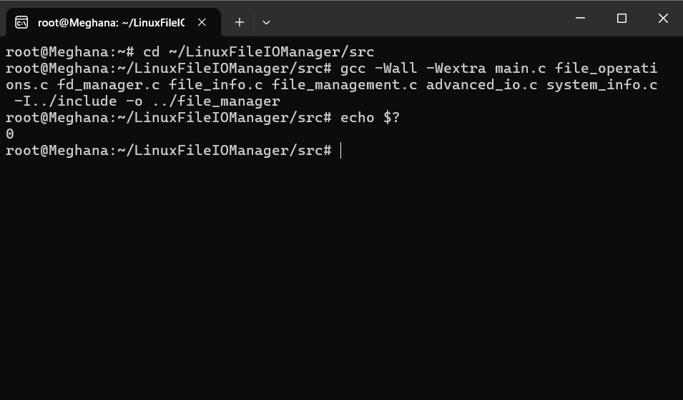
Screenshot 2 – Main Menu
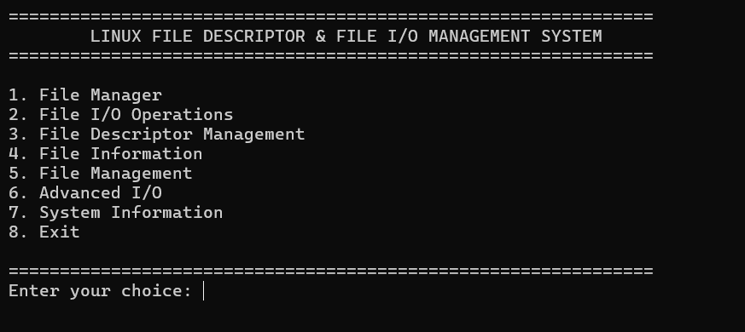

Screenshot 3 – File Manager
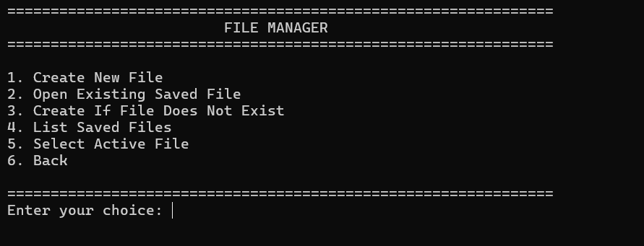
Screenshot 4 – File I/O Operations
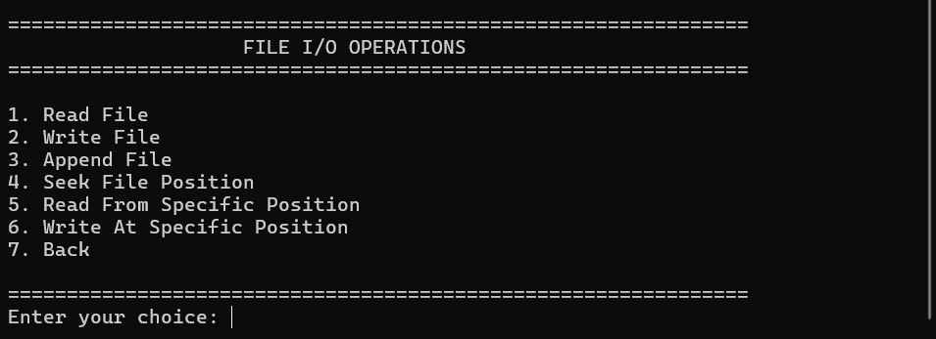
Screenshot 5 – File Descriptor Management
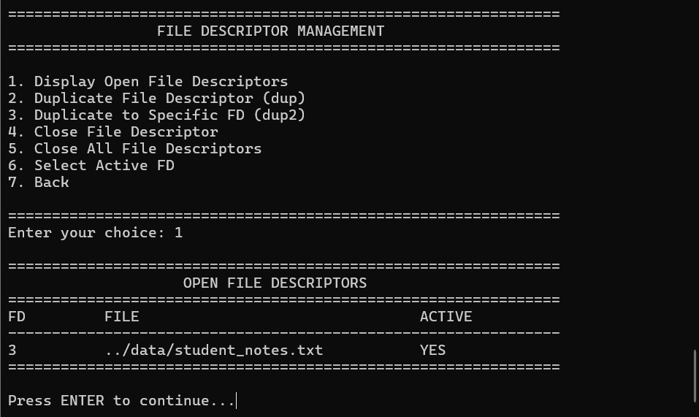
Screenshot 6 – File Information
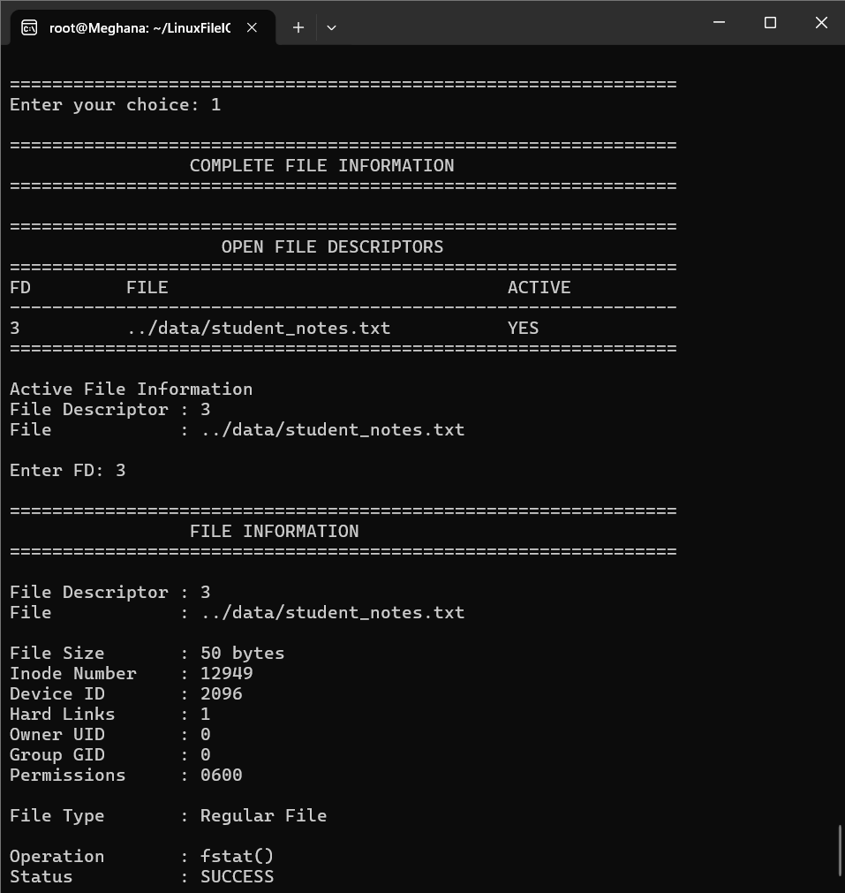
Screenshot 7 – File Management
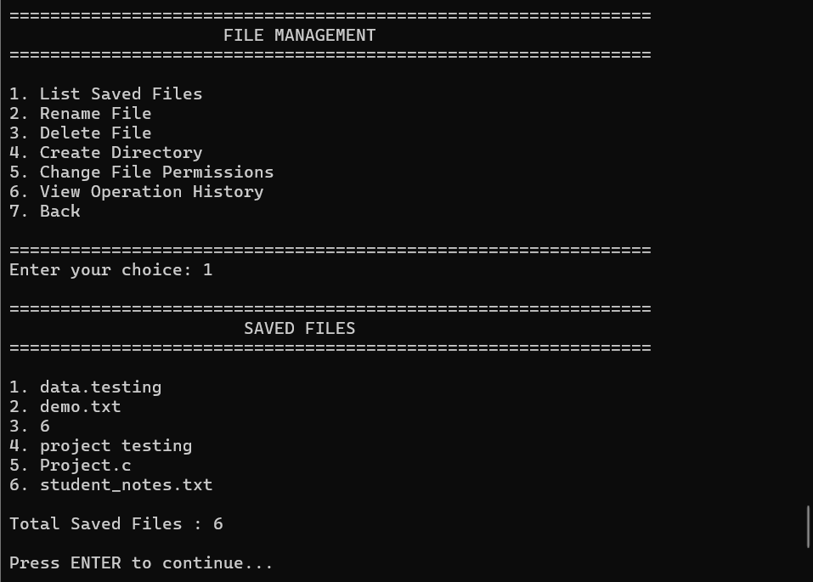
Screenshot 8 – Advanced I/O
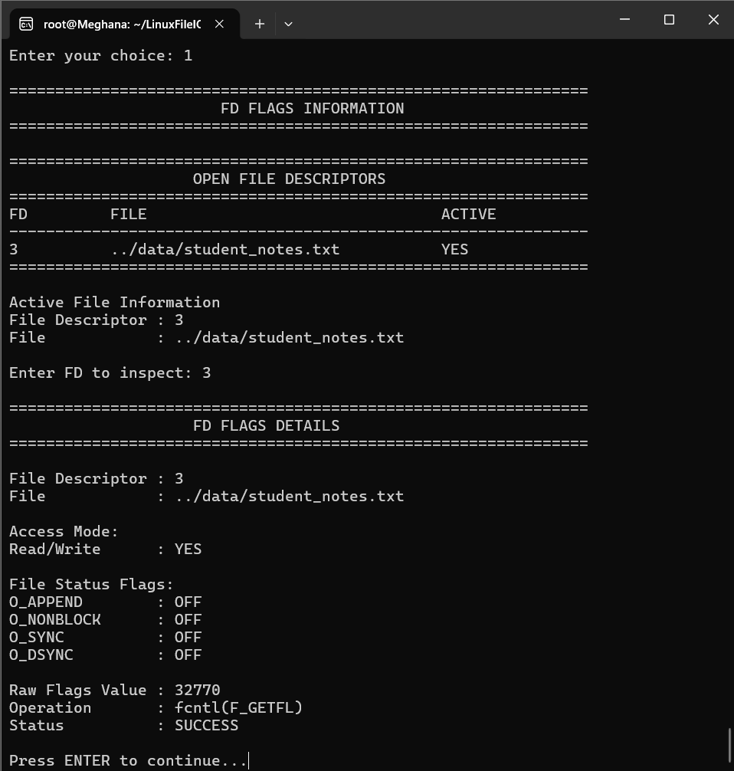
Screenshot 9 – System Information
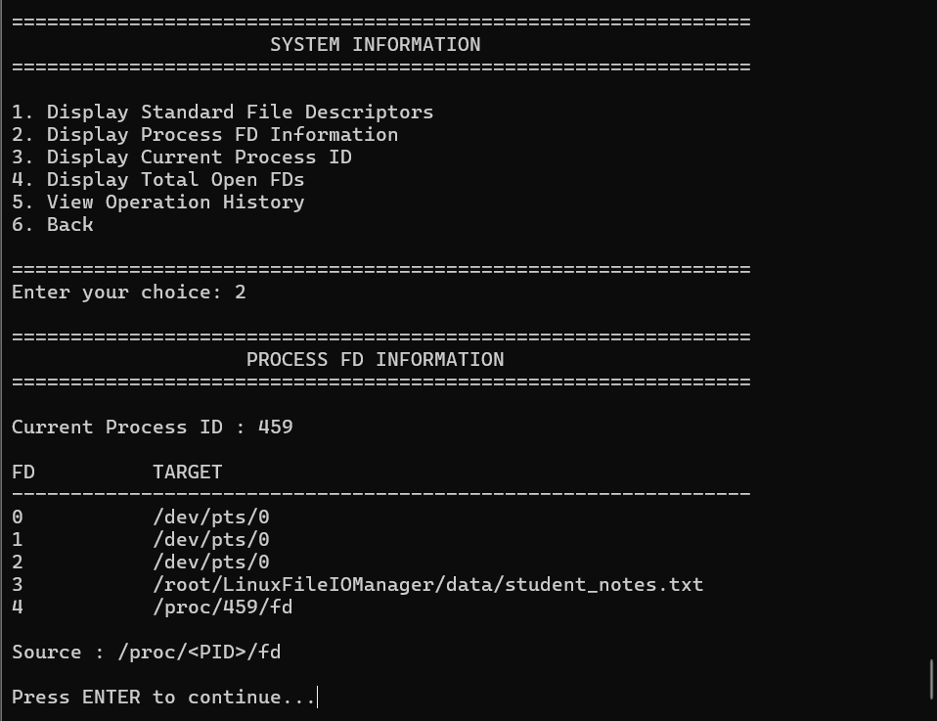
These screenshots provide visual evidence that the implemented features were executed successfully.

7.5 Demonstration of OS Concepts
The project demonstrates several important Operating Systems concepts.
OS Concept | Demonstration in Project
System Calls | open(), read(), write(), close() and other Linux APIs
File Descriptors | Integer descriptors returned when files are opened
File I/O | Reading, writing and appending data
File Offset | lseek() changes the current file position
FD Duplication | dup() and dup2()
File Permissions | chmod() and permission display
File Metadata | fstat()
File Locking | fcntl()
Synchronization | fsync()
File Size Management | ftruncate()
Process Management | getpid() and /proc/<PID>/fd
Resource Management | close() and Close All FDs
Error Handling | Return-value checking and validation
The project therefore provides practical demonstration of the relationship between a user program, Linux system calls, file descriptors, the Linux kernel, and the file system. Linux_File_Descriptor_and_File_…

7.6 Testing and Validation
The application was tested module by module in Ubuntu.
The testing process included:
- Compiling all C source files.
- Starting the application.
- Testing each main-menu module.
- Creating and opening files.
- Performing read/write/append operations.
- Testing file positions.
- Testing FD duplication and closing.
- Checking file information.
- Testing rename, delete and directory operations.
- Testing advanced I/O operations.
- Checking process and FD information.
- Verifying operation history.
The successful execution of these tests confirmed that the major project features were functioning as intended.

7.7 Chapter Summary
This chapter described the execution and demonstration of the Linux File Descriptor and File I/O Management System in Ubuntu Linux.
The project was successfully compiled using GCC and executed through the Ubuntu terminal. The implemented modules were tested individually, including file I/O, file-descriptor management, file information, file management, advanced I/O, and system information.
The testing demonstrates practical Operating Systems concepts such as system calls, file descriptors, file offsets, permissions, resource management, process information, and error handling.
H

CHAPTER – 8
CONCLUSION AND FUTURE SCOPE
8.1 Summary of the Project
The Linux File Descriptor and File I/O Management System was successfully developed as a C-based Operating Systems project in the Ubuntu Linux environment. The project provides a menu-driven interface for managing files and demonstrating Linux file descriptors and system calls.
The system supports file creation, opening, reading, writing, appending, seeking, and closing. It also provides features for file-descriptor management, file information, file management, advanced I/O operations, and system information.
The project provides practical understanding of how a user program communicates with the Linux kernel through system calls and how file descriptors are used to access files. The project was implemented and tested using GCC in Ubuntu Linux. Linux_File_Descriptor_and_File_…

8.2 Objectives Achieved
The major objectives of the project were successfully achieved.
- Implemented file creation and opening using Linux system calls.
- Implemented reading, writing, appending, and seeking operations.
- Demonstrated file descriptor creation and management.
- Implemented FD duplication using dup() and dup2().
- Implemented file information using fstat().
- Implemented file rename, deletion, directory creation, and permission changes.
- Demonstrated advanced operations such as file locking, synchronization, and truncation.
- Displayed process ID and process file-descriptor information.
- Implemented persistent operation history.
- Compiled and tested the complete application in Ubuntu Linux.
These features extend the basic file-I/O objectives described in the original project documentation and provide a more complete practical demonstration. Linux_File_Descriptor_and_File_…

8.3 Results Achieved
The developed system successfully provides a practical environment for understanding Linux file management and file descriptors.
The project demonstrates the complete relationship:
User
↓
C Application
↓
Linux System Calls
↓
File Descriptor
↓
Linux Kernel
↓
File System
During testing, the major modules were executed successfully. File operations, descriptor management, file information, file management, advanced I/O, and system information were verified through the Ubuntu terminal.
The project therefore connects theoretical Operating Systems concepts with practical Linux system programming. It also provides hands-on experience with GCC, Linux commands, file permissions, system calls, and process-level file-descriptor management. Linux_File_Descriptor_and_File_…

8.4 Skills and Learning Outcomes
The project helped in developing practical knowledge in the following areas:
- C programming for system-level applications.
- Linux/POSIX system calls.
- File descriptor concepts and management.
- File reading, writing, appending, and seeking.
- Linux file permissions and metadata.
- Process and /proc file-descriptor information.
- Error handling and resource management.
- GCC compilation and Ubuntu terminal usage.
- Git and GitHub for project source-code management.
The project also improved understanding of how operating-system services are accessed by user programs through system calls.

8.5 Future Enhancements
Although the current system provides a complete practical implementation, it can be extended further.
Possible future enhancements include:
- Adding a more advanced terminal dashboard for active files and FDs.
- Supporting simultaneous management of a larger number of files.
- Adding more detailed error-reporting and logging.
- Adding advanced file-search and filtering features.
- Adding additional Linux system calls for further experimentation.
- Extending the project with process-management and IPC demonstrations.
- Adding a graphical interface for easier file management.
- Providing more detailed statistics about file-descriptor usage.
These enhancements can make the system more suitable for demonstrating advanced Operating Systems and Linux system-programming concepts. Linux_File_Descriptor_and_File_…

8.6 Conclusion
The Linux File Descriptor and File I/O Management System successfully achieves its objective of providing a practical demonstration of Linux file descriptors, file I/O, and system calls.
The project demonstrates how files are created, accessed, modified, managed, and closed through Linux system-level operations. By implementing these concepts in C and testing them in Ubuntu, the project provides a clear connection between Operating Systems theory and practical programming.
Overall, the developed system serves as a useful educational application for understanding file descriptors, Linux system calls, file management, resource management, and low-level I/O operations.

CHAPTER – 9
REFERENCES
9.1 Books
- Abraham Silberschatz, Peter B. Galvin and Greg Gagne, Operating System Concepts, Wiley.
- W. Richard Stevens and Stephen A. Rago, Advanced Programming in the UNIX Environment, Addison-Wesley.
- Brian W. Kernighan and Dennis M. Ritchie, The C Programming Language, Prentice Hall.

9.2 Linux / GNU Documentation
- Linux Manual Pages (man pages) – Documentation for Linux system calls and library functions such as open(), read(), write(), close(), lseek(), dup(), dup2(), fcntl(), fstat(), fsync(), and ftruncate().
- GNU Compiler Collection (GCC) Documentation – Used as a reference for compiling and building the C source files.
- Ubuntu Linux Documentation – Used for understanding the Ubuntu environment, terminal commands, file permissions, and system-level execution.

9.3 Linux System Calls and POSIX References
The following Linux/POSIX APIs were referred to during the implementation:
- open() – File creation and opening.
- read() – Reading file data.
- write() – Writing file data.
- close() – Closing file descriptors.
- lseek() – Changing file position.
- dup() – Duplicating file descriptors.
- dup2() – Duplicating a descriptor to a specified number.
- fstat() – Obtaining file information and metadata.
- rename() – Renaming files.
- unlink() – Deleting files.
- mkdir() – Creating directories.
- chmod() – Changing file permissions.
- fcntl() – File-descriptor control and file locking.
- fsync() – Synchronizing file data.
- ftruncate() – Changing file size.
- getpid() – Obtaining the current process ID.
These references supported the implementation and testing of the Linux File Descriptor and File I/O Management System. Linux_File_Descriptor_and_File_…

9.4 Linux Commands and Utilities
The following Linux commands were used during project development and testing:
cd
gcc
echo
ls
cat
chmod
mkdir
ping
git
These commands were used for navigating the project directory, compiling the program, checking compilation status, viewing files, managing permissions, testing the Ubuntu environment, and maintaining the project repository.

9.5 Project Repository
The project source code was maintained using Git and uploaded to the team's GitHub repository.
GitHub Repository:
Linux File Descriptor and File I/O Management System
Repository:
https://github.com/kupireddyakshithareddy-sketch/Linux-File-Descriptor-and-File-I-O-Management-System
GitHub was used for source-code storage and version management during the project. Linux_File_Descriptor_and_File_…

9.6 Online Resources
The following online resources were used as supporting references during the development and testing of the project:
- Linux/POSIX system-call documentation.
- GNU C Library documentation.
- GCC documentation.
- Ubuntu Linux documentation.
- Git and GitHub documentation.
These resources helped in understanding Linux file operations, system calls, compilation, terminal usage, permissions, and source-code management.

9.7 Reference Summary
The references used for this project provided information related to:
Reference Area | Purpose
Operating Systems Books | Understanding file systems, processes and resource management
C Programming | Implementing the project modules
Linux Man Pages | Understanding system calls and their usage
GCC Documentation | Compiling the C source code
Ubuntu Documentation | Linux environment and terminal operations
Git/GitHub Documentation | Source-code management and repository maintenance
The above references supported the development, implementation, testing, and documentation of the Linux File Descriptor and File I/O Management System.

APPENDIX – A
QUICK VIVA / DEMONSTRATION NOTES
Question | Short Answer
What is a file descriptor? | An integer handle used by a process to access an open file or I/O resource.
What does open() return? | A non-negative file descriptor on success; -1 on failure.
Why is O_CREAT used? | To create the file if it does not already exist.
Why is O_APPEND used? | To make writes occur at the end of the file.
What does O_TRUNC do? | It removes existing file contents when the file is opened with appropriate write access.
Why use read() and write()? | They demonstrate low-level Linux/POSIX file I/O through file descriptors.
Why use close()? | To release the file descriptor after use.
What is 0644? | A common permission mode used when creating a file.
Why Ubuntu? | The project depends on Linux/POSIX system calls and is intended for Linux execution.
How is the project compiled? | Using GCC with all project source files:  gcc -Wall -Wextra main.c file_operations.c fd_manager.c file_info.c file_management.c advanced_io.c system_info.c -I../include -o ../file_manager

ANNEXURE – A
PROJECT PROBLEM STATEMENT DETAILS
A.1 Course and Team Details
Item | Details
Course | Operating Systems and Systems Programming (25CS2104E)
Academic Year / Term | 2026–27, Term-I
Section No. | 7
Team No. | 10
Project Title | Linux File Descriptor and File I/O Management System
Team Member 1 | K. Akshitha – 2520030233
Team Member 2 | T. Meghana Sai – 2520030245
A.2 Abstract
Linux File Descriptor and File I/O Management System is a Linux-based system programming project designed to demonstrate how files are managed using file descriptors and Linux system calls. The system provides a simple interface to perform common file operations such as creating, opening, reading, writing, appending, seeking, and closing files.
The system also demonstrates file descriptor management and provides information about files and their associated descriptors. The project uses Linux/POSIX system calls such as open(), read(), write(), close(), lseek(), dup(), dup2(), and fstat(). The main purpose is to provide practical understanding of file descriptors, file I/O, system calls, and the interaction between user programs and the Linux operating system.
The proposed system is implemented using C on Ubuntu Linux. The expected outcome is a functional application that allows users to perform file I/O operations while observing how Linux assigns and manages file descriptors. The project demonstrates important Operating Systems and Systems Programming concepts through practical implementation.
A.3 Problem Statement
In Linux, files are accessed and managed by processes using file descriptors and system calls. However, understanding how file descriptors are created, used, and managed during file input and output operations can be difficult for beginners. Common file operations such as opening, reading, writing, seeking, and closing are performed through different system calls, making it difficult to understand the complete interaction between a user program and the Linux operating system.
Therefore, the project develops a Linux-based File Descriptor and File I/O Management System that provides a simple interface for performing and observing various file operations. The system demonstrates how Linux manages file descriptors and handles file input/output through system calls, providing practical understanding of important Operating Systems and Systems Programming concepts.
A.4 Objectives
- To develop a Linux-based system for managing files using file descriptors.
- To implement file I/O operations such as opening, reading, writing, appending, seeking, and closing files using Linux system calls.
- To demonstrate Linux/POSIX APIs such as open(), read(), write(), close(), lseek(), and dup() for file and descriptor management.
- To understand how Linux manages file descriptors and handles file I/O between user programs and the operating system.
A.5 Proposed Methodology
The proposed system is developed as a Linux-based application using C. It provides a simple menu-driven interface for performing file management and file I/O operations. The user can create or open a file, after which Linux assigns a file descriptor to the opened file.
The system uses Linux system calls such as open(), read(), write(), lseek(), dup(), and close() to perform different operations. File information is displayed to the user, and appropriate error messages are provided when an operation fails. The application demonstrates the complete interaction between the user program, Linux system calls, file descriptors, and the file system. The system is tested on Ubuntu Linux to verify the correctness of each file operation.
A.6 Operating Systems Concepts / Linux APIs Used
OS Concept / Linux API / System Call | Purpose in the Project | Role
File Descriptor | Used to identify and manage opened files. | Core OS concept
open() | Used to create or open a file and obtain a file descriptor. | File access
read() | Used to read data from a file using its file descriptor. | Input
write() | Used to write data into a file using its file descriptor. | Output
lseek() | Used to change the current position of the file for reading or writing. | File positioning
close() | Used to close the file and release the file descriptor. | Resource release
dup() | Used to duplicate an existing file descriptor. | Descriptor management
dup2() | Used to duplicate a descriptor to a specified descriptor number. | Descriptor management
fstat() | Used to obtain file information and metadata. | File information
A.7 Individual Contribution
Roll Number | Student Name | Individual Responsibility
2520030233 | K. Akshitha | Design and implementation of file creation, opening, reading and writing operations using open(), read() and write().
2520030245 | T. Meghana | Implementation of file descriptor management, file seeking and closing using lseek(), dup() and close(), along with testing and documentation.
A.8 Tools / Platforms / Software Used
Tool / Platform / Software | Purpose
Linux / Ubuntu | Operating system environment for developing and executing the project.
C | Used to implement file I/O operations and Linux system calls.
GCC Compiler | Used to compile and run the C source code.
GitHub | Used for storing and managing the project source code.
A.9 Expected Outcome
- A functional Linux-based File Descriptor and File I/O Management System.
- The system allows users to create, open, read, write, append, seek, and close files using Linux system calls.
- The system displays file descriptor information and provides appropriate messages for successful and failed operations.
- The project demonstrates practical understanding of file descriptors, file I/O, Linux system calls, and file management.
- The project helps users understand how a program interacts with the Linux operating system while performing file-related operations.
A.10 GitHub Repository
GitHub Repository: https://github.com/kupireddyakshithareddy-sketch/Linux-File-Descriptor-and-File-I-O-Management-System
Repository status in the project submission form: Created / available.
A.11 Faculty Approval Details
Faculty Name: ______________________________________________
Signature: _________________________________________________
Remarks: ___________________________________________________
Project Approved: Yes / No
Date: ______________________________________________________
Faculty Signature: __________________________________________

